______

*Corresponding author: Nihar Pandya: HFU, Jakob-Kienzle-Straße 17 78054 VS-Schwenningen e-mail: niharpandya087@gmail.com

Nihar Pandya

Temporal Recruitment Modelling of Modified Hickling Model of ARDS Lung

Abstract: Introduction: There are a few methods to measure the volume inside the lungs. Hickling introduced a simple first order model (FOM) to demonstrate the effects of airway pressure on the volume in a patient with an ARDS lung **[1]**. Methods: The model will now extend to include the temporal recruitment process. The opening of an alveoli on a layer is not purely based on pressure but on the pressure-time integral. Just in case that pressure is long enough present, an opening of alveoli is enforced. Discussion: In figure 4 it is noticed that there is a slight deviation between the PV curve of the original model and the model with recruitment due to the varying times needed to open an alveoli and the simulation time set. Conclusion: The recruitment model developed was able to highlight the importance of the opening and closing of the alveoli on the Hickling model.

Keywords: Gaussian distribution, Hickling ARDS model, Lung model, Temporal Recruitment.

1. Introduction

There are a few methods to measure the volume inside the lungs. Hickling introduced a simple first order model (FOM) to demonstrate the effects of airway pressure on the volume in a patient with an ARDS lung **[1]**. Hicklings model also included the threshold opening pressures (TOP) of an alveoli which had a significant impact on the volume. The model was later enhanced by Salazar and Knowles equation to transfer the model from a linear compliance to a nonlinear compliance **[2]**. These 2 methods gave a relevant structure into enhancing our lung model even more. The models did not introduce a key factor that is the recruitment and derecruitment of the air spaces at the level of the alveoli.

Recruitment and Derecruitment are governed by the opening and closing pressures of the alveoli **[3]**. The view of this phenomena is that a recruitment process which occurs during inflation for a closed alveoli, takes place when the effective pressure reaches a certain critical value after which the lung unit opens and receives the administered volume. The derecruitement acts during the deflation or expiration phase when the effective pressure drops below the critical value needed to keep the alveoli open and therefore the alveoli closes.

A modified Hickling, Salazar Knowles model was implemented to incorporate pressure as time dependent, and not just a predefined range. The model is now modified further to include temporal recruitment. In temporal recruitment the theory states that recruitment is often delayed, since the gas must first remove fluid from a bronchiole before reaching the alveoli.

1. Methods

As a first step time dependent pressure model of Hicklings and Salazar, Knowles modification equation was implemented in Matlab.

$\dot{p_{a}}= \frac{\dot{V}}{C_{FOM}}$ (1)

$p_{aw}= R_{FOM}\dot{V}+ p_{a}$ (2)

Where $\dot{p_{a}}$ is the derivative of the alveolar pressure, $\dot{V}$ is the flow rate (ml/s), $R_{FOM}$ is the bronchial resistance at a certain level (cmH2o*s/cm3), and is the airway pressure (cmH2o). $C_{FOM}$ represents the first order model of the compliance, that is the calculated based on Hicklings model.

$C_{FOM}= \frac{V}{p_{efective}}$ (3)

Where $V$ is the volume inside the lung unit, and $p_{efective}$ is the effective pressure at the lung layer, which is the alveolar pressure minus the superimposed pressure (SP). The Volume $V$ is calculated using Hiklings FOM model with Salazar Knowles modification.

$V= \frac{A-Be^{-k\left(p_{efective}\right)}}{\left(1+Opmax-Opmin\right)}\left(LungLevelUnits\right)$ (4)

Where A and B are the maximal volumes, K is a constant, Opmax and Opmin represents the maximum and minimum pressures required to open an alveolar unit. The lung level units is the number of alveoli in each layer. The built-in Matlab function of ode45 that implements the Runge-Kutta method was used to compute the ordinary differential equation (1), the output is the time dependent airway pressures.

The model will now extend to include the temporal recruitment process. The opening of an alveoli on a layer is not purely based on pressure but on the pressure-time integral. Just in case that pressure is long enough present, an opening of alveoli is enforced. A mechanism is implemented to calculate and store for every layer the duration of effective pressure being present. An auxiliary variable (“Open”) is considered which integrates the weighted pressure-difference of current Pressure $p_{efective}$ and the TOP ($p_{threshold}$) for a given layer.

$\dot{Open}= s_{o}*\left(p_{efective}- p_{threshold}\right)$ (5)

$${∀ p}_{efective}> p_{threshold}$$

$\dot{Open}= s_{c}*\left(p_{efective}- p_{threshold}\right)$ (6)

$${∀ p}_{efective}< p_{threshold}$$

Equation 5 represents the equation for the recruitment temporal model while equation 6 represents the derecruitment model. The parameter $s_{o}$ and $s_{c}$ are respectively the rates at which the opening and closing velocities increase as $p_{efective}$ moves away from **[3]**.

Open = 0 Deflation Open = 1

Closed Inflation Open

Figure 1 Diagram of Open variable representing opening and closing cycle of an alveoli

As seen in Fig. 1 when moving from an Open value of 0 to Open value of 1, this simulates inflation, i.e. recruitment that is opening of the alveolar unit. When moving from an Open Value of 1 to an Open value of 0, this simulates the deflation, i.e. derecruitment, or closing of the alveolar unit. The models mentioned will be implemented in Matlab, and the analyses of the pressure vs. volume curves (P/V) as well as the Open variable curves for certain lung layers will be performed.

A Normal Cumulative distribution, i.e. Gaussian distribution curve will also be performed on every layer of the lung at each pressure.

1. Results
   1. Raw Data

The volumetric flow rate is given as a step function for 2 seconds of 500 ml/s and then a pause of 2 seconds for a rate of 0 ml/s this combination simulates a constant flow ventilation followed by an end inspiratory pause respectively. The peak end expiratory pressure (PEEP) is set as 0 for start of calculations, then more analyses using different PEEP levels of 5, 10 and 15 is done to see the difference in the P/V curves and how the model is affected. The $R_{FOM}$ was calculated using Horsefield and Cummings equation for R at a brionchiole level of 23 with diameter 0.274 cm and length of 0.328 cm, the viscosity of gas was taken as 10-4 g/cms. The value of R is 0.00023 cmH2o.s/cm-3.

For the volume calculation A and B were taken as 0.0072, and the value of K as 0.078. The time interval for the calculation of the ode45 model of equation (1) was taken from 0 to 4 seconds with an interval of 0.01 seconds. At the early stage a TOP of 0 is set, then simulated for different TOPs of 5, 10 and ranges of TOP of 3:10, and 5:10, where 3, 5 represent Opmin, the minimum TOP and 10 represents Opmax, the maximum TOP.

The constants $s_{o}$ and $s_{c}$ where taken to be 50 and 50 respectively. They were later modified to 25, 15, and 100 each to see the effect on the P/V curves. Lung Level Units per layer were taken as 9000 units, the number of Lung Layers is taken as 31 ranging from -0.5 by 0.5 to 14.5.

* 1. Analyzed Data

Figure 2 represents the time required to open an alveoli for Airway Pressure ranges (Paw) from 0 to 25 cmH2o at lung layer 31, which is the last lung layer. The time taken for the alveoli to open increases until a pressure of 15 cmH2o is reached, after which the time required decreases until reaching values below 0.1 seconds.

In the derecruitment process the time has a range between 0.15 and 0 seconds. The time is decreasing gradually from the initial pressure of PEEP until it reaches a pressure of 15 cmH2o where it continues as 0 afterwards. Figures 1 and 3 where simulated using a TOP of 0 and PEEP ranges 0,5,10 and 15, and an $s_{o}$ of 25 and $s_{c}$ of 50. Figure 4 was simulated with same parameters as 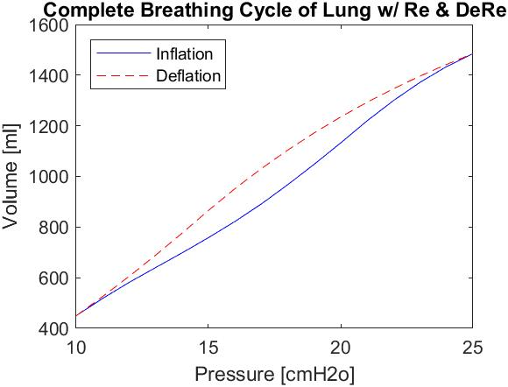Figures 2 and 3 but with a TOP range of 3:10 and PEEP of 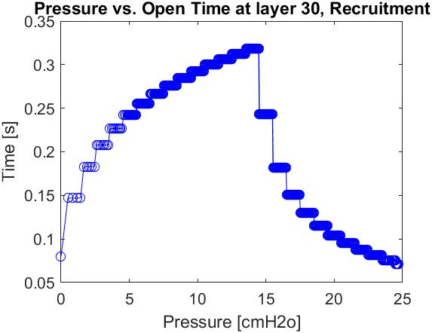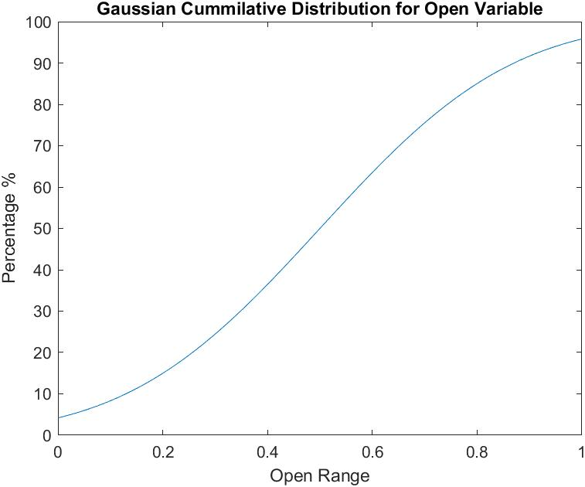10 cmH2o.

Figure 2 Airway Pressure vs. Opening Times at the last layer (31), image also illustrates the maximum times at every other SP before the 15 cmH2o

Figure 4 represents the complete breathing cycle of the lung, the blue curve illustrates inflation while the red dashed curve represents the deflation

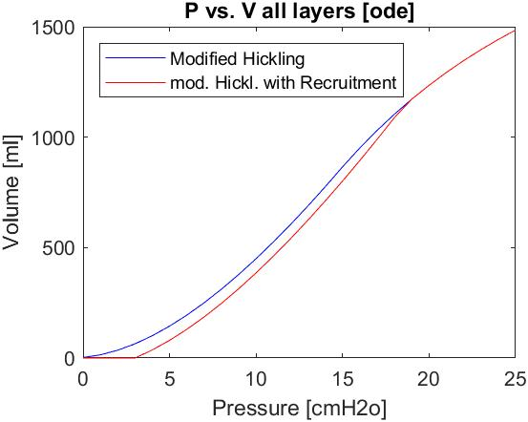Figure 3 represents the PV curve of both the modified Hickling model and the modified model with recruitment. The pressure ranges are between 0 and 25 cmH2o. The volume range is between 0 and 1500 ml. The red curve represents the model with recruitment while the blue curve represents the regular model with no recruitment. The model with recruitment is starting with a volume at a pressure of around 3 cmH2o and continues near parallel to the original model until reaching a pressure of 19 cmH2o after which both curves converge.

Figure 5 Gaussian Cumulative Distribution of Open Variable

Figure 4 represents the complete breathing cycle of a lung. The pressure ranges between 10 and 25 cmH20, with the volume ranging between 420 to 1500 ml. The Blue curve represents the inflation while the Red dashed curve represents the deflation part.

Figure 5 represents the Gaussian Cumulative distribution curve with respect to the Open variable, using the mean and standard deviation of the open variable ranges from 0 to 1 by an increment of 0.01 to make the graph smooth.

1. Discussions

Figure 3 represents the PV curve of both models. The Blue curve represents the original model, and the Red curve represents the recruitment model

* 1. Results Summary

It is noticed from figure 2 that when small pressures are applied the time to open an alveoli is small but as we increase the pressure the time increases until we reach the pressure of 15 cmH2o after this pressure, the superimposed pressures, which is 14.5 at the last layer, are being overcome therefore the time for opening the alveoli keeps decreasing as we keep increasing the pressure. At different layers different variations of time occur but they follow the same pattern as of figure 2. The values of time preceding the 15 cmH2o pressure, are the maximal values of time for the alveolar openings at each SP.

For derecruitment it was noticed that the times are decreasing as the pressure is increasing, this means that the time needed for the alveoli to collapse is decreasing but after a pressure of 15 cmH2o the alveoli will not be collapsing and will remain open, which is represented by a time of 0.

It was also noticed that the $s_{o}$ and $s_{c}$ played a key role in speeding up and slowing down the times needed to open and collapse. When the values of $s_{o}$ and $s_{c}$ decrease the time range increases while if the values increase the time is faster. The TOP also plays a crucial role in the calculations, the start time of the opening of the alveoli is shifted to the value of the TOP rather than PEEP. This means that when the PEEP is less than the TOP the alveoli was unable to open.

In figure 3 a slight deviation between the PV curve of the original model and the model with recruitment is seen. This small deviation is due to the opening times, as some opening times are higher at some pressures, than the time of the simulation, which was 0.01 seconds. This will lead to a shift in the curve to the right at the start and it will run parallel to the original until the time drops below the input time which occurs at Paw of 19 and it continues along the same curve of the original model.

In figure 4 a complete cycle for breathing was created. It is observed from the figure that the inflation curve has a somewhat lower curve and amplitudes for volume than the deflation curve. This is due to the TOP values, as we need pressures to overcome the SP and TOP pressures in order to have volume inside the lung and to open alveoli, but for deflation the peak inspiratory pressure, here 25 cmH2o, has to overcome the maximum TOP and SP, and the Paw should be greater than the SP in order to have volume inside. When the TOP was set to 0 cmH2o then the inflation and deflation curves coincided with each other.

It is seen in figure 5 that when we are at the Open variable of 0 the Gaussian distribution is low and when we are at Open value of 1 the Gaussian distribution is around 95%. This means that at an Open value of 0 less than 5% of the alveoli are open while when the value of 1 is reached for open more than 95% of our alveoli are open.

* 1. Study Limitations

Some study limitations were taken into account. The values of the Paw were rounded to the nearest integer in order to get smooth curves, as the values returned from the ode45 computation were in the 4th decimal positions that were giving some outliers and hindering the performance of the results. Another limitation is that it was assumed that a lung is made of 31 layers and we have an increasing SP based on Hicklings model.

1. Conclusion

The recruitment model developed was able to highlight the importance of the opening and closing of the alveoli on the Hickling model. Temporal Recruitment and derecruitment are having an effect on the PV curves therefor they must be considered in calculations. More research still needs to be done in order to get more accurate and reliable results.

Acknowledgment

This paper has been submitted to the course: Physiological Modelling (Summer Semester 2020). The authors confirm that this assignment is their own work, is not copied from any other person’s work (published or unpublished) and has not been previously submitted for assessment either at Furtwangen University (HFU) or elsewhere.

Author’s Statement

Research funding: The authors state no funding involved. Conflict of interest: Authors state no conflict of interest. Informed consent: Informed consent has been obtained from all individuals included in this study.  
Ethical approval: The research related to human use complies with all the relevant national regulations, institutional policies and was performed in accordance with the tenets of the Helsinki Declaration, and has been approved by the authors' institutional review board or equivalent committee.

References

1. Keith G. Hickling, The Pressure-Volume Curve is Greatly Modified by Recruitment. AM J RESPIR CRIT CARE MED 1998;158:194-202
2. SALAZAR E, Knowles JH. An Analysis of Pressure-Volume Characteristics of the Lungs. J Appl Physiol. 1964;19:97-104. doi:10.1152/jappl.1964.19.1.97
3. Bates J., Irvin C. Time Dependence of Recruitment and Derecruitment in the lung: a theoretical model. J Appl. Physiol 93: 705-713,20